W-20

**YEAR 12 PHYSICS**

**ASSIGNMENT 1 - MOTION**

**Name:** **Mark:**

1. A cannon fires a cannon ball horizontally at speed of 50.0 ms-1 from the top of a bridge that is 1.00 x 102 m above the surface of a lake below. Ignoring air resistance, calculate the velocity of the cannon ball just before it hits the water. (5 marks)

4. A 53 kg skater is attempting to complete a loop that is 2.50 m in radius. ***Estimate*** the minimum speed at the top of the loop needed for the skater to maintain contact with the top of the loop. (5 marks)

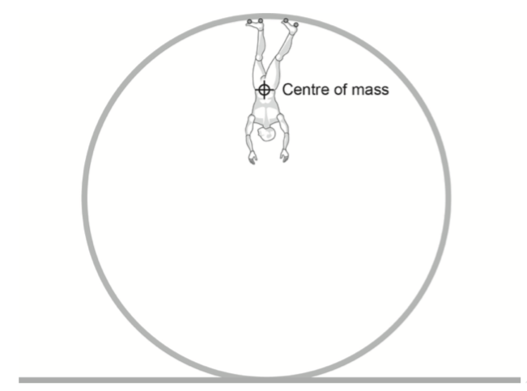

3. The diagram below shows the forces acting on a car following a curve on a banked track. The car is travelling at 17.0 ms-1 without slipping. Calculate the radius of the track.

(5 marks)

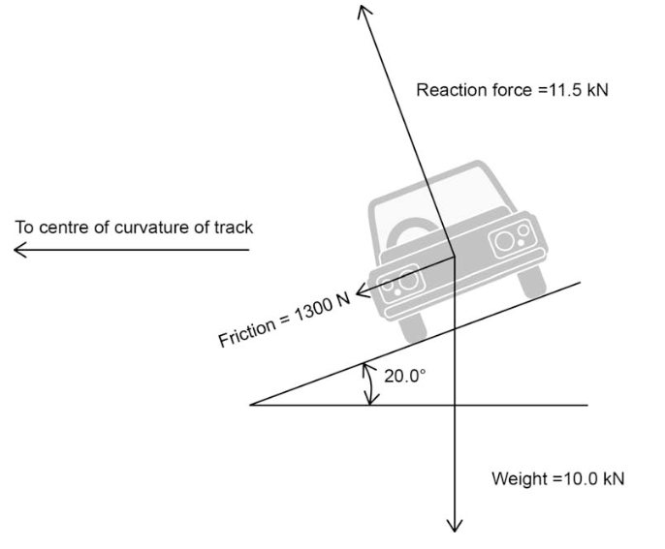

4. An aircraft is flying horizontally with a constant speed of 600 kmh-1 at an altitude of 5000 m. The upward (lift) force provided by the wings that is necessary to keep the aircraft in level flight is 9.80 × 104 N.

(a) Show that the mass of the aircraft must be 1.00 × 104 kg. (3 marks)

(b) The pilot begins a turn by tilting the aircraft so that its wings are at 15.0° to the horizontal as shown. Assume that the airspeed does not change, and that the size and angle to the wing of the lift force remain constant.

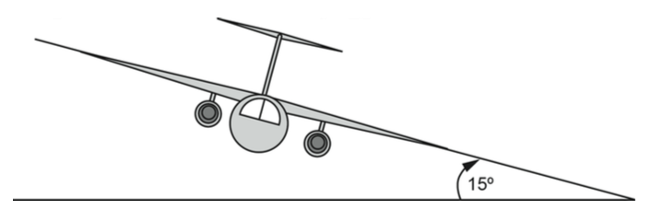

Draw a free body diagram below labelling the forces acting on the aircraft. Ignore drag/friction and thrust forces directed into and out of the page. (2 marks)

(c) Calculate the horizontal radius of the aircraft’s turn, assuming the airspeed does not change. (5 marks)

(d) Describe any effects that this turn will have on the altitude of the aircraft. No calculations are required. (2 marks)

5. A student is conducting an experiment by tying a rubber stopper to a string and swinging it in a horizontal circle as shown in the diagram below. The stopper has a mass of 0.123 kg and the distance along the string from the pivot to the centre of mass of the stopper is 1.43 m.

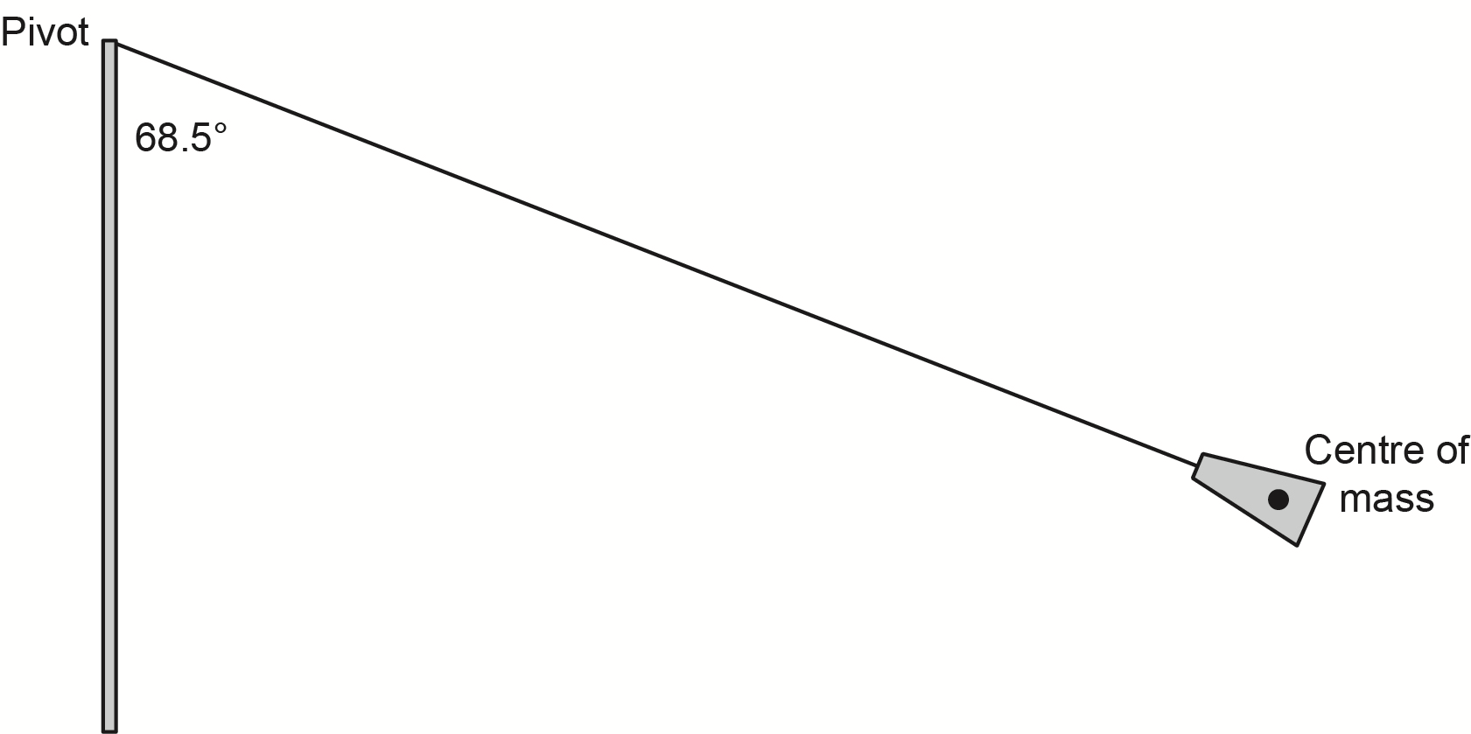page25image64196992

(a)   On the diagram, draw and label the forces acting on the stopper. (2 marks)

(b)   Show that the tension in the string is 3.29 N. (2 marks)

(c)   Calculate the speed of the stopper. (4 marks)

6. A firework rocket was launched into the air from the ground at point A with an initial velocity  
 of 30.0 m s-1 at an angle of 70.0° to the horizontal. When the firework rocket reached its initial maximum height at point B, there was a second explosion that further propelled the upper part of the firework rocket with a new velocity of 20.0 m s-1 at an angle of 45.0° to the horizontal. This upper part of the firework rocket was propelled to a new maximum height at point C where the firework rocket exploded. Ignore all effects due to air resistance.

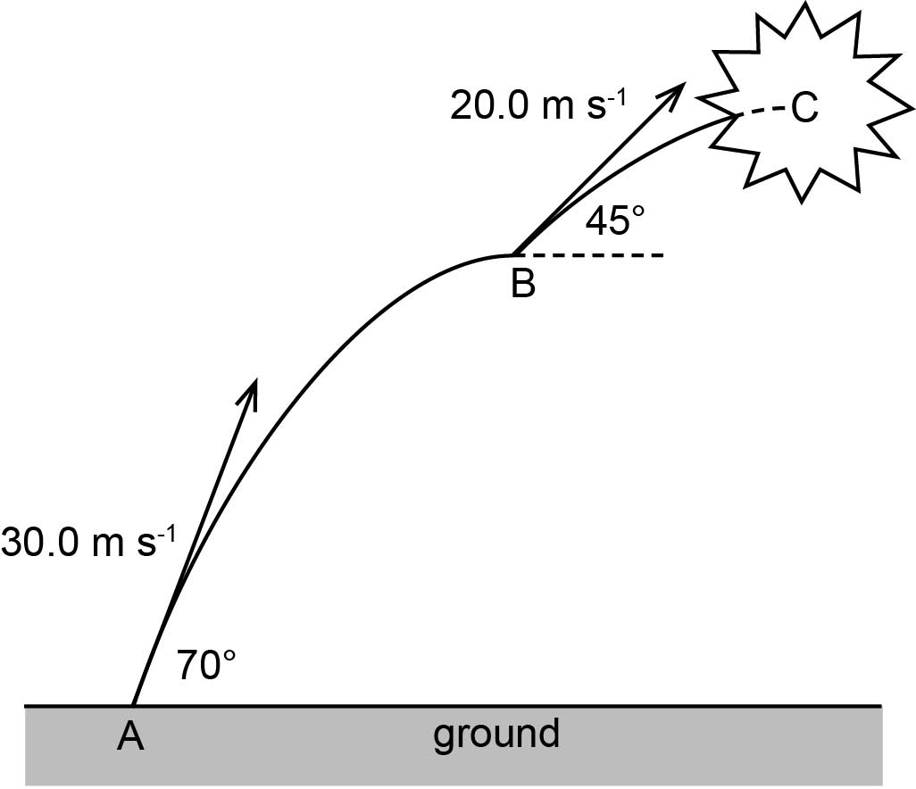

(a) Determine the initial vertical velocity of the firework rocket. (2 marks)

(b) Calculate the height of point B. (3 marks)

(c) Calculate the total time it takes for the firework rocket to reach point C where it explodes. (5 marks)

(d) Use the axes below to sketch a graph of vertical velocity against time of the firework from immediately after it is launched at point A until it reaches point C. Use appropriate values and ignore all effects due to air resistance. (3 marks)

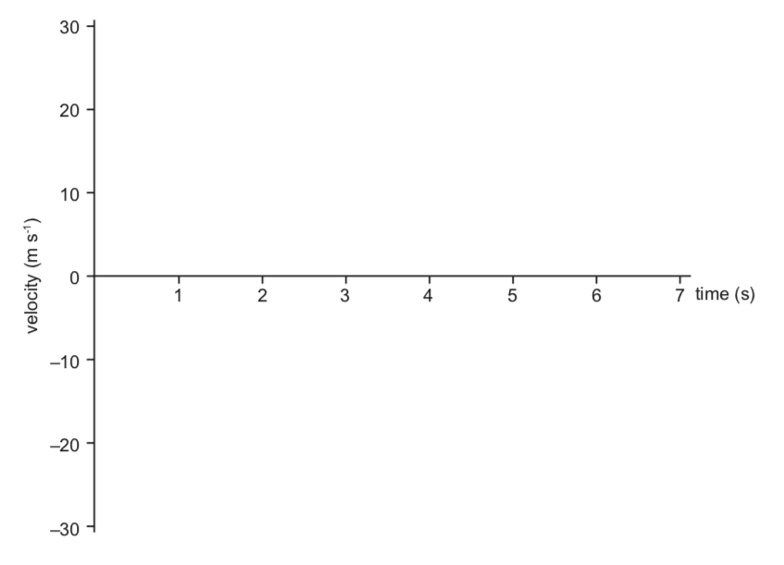

7. A ball is rolled from rest down a curved slope, across a flat, smooth table leaving the table horizontally and falling to the floor.

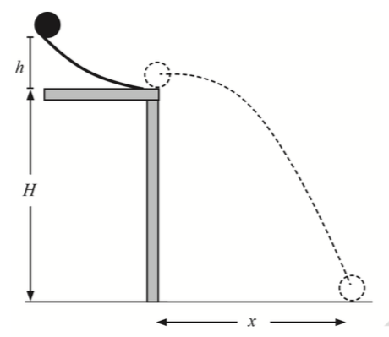

If *h* = 30.0 cm and *H* = 1.20 m:

(a) Using conservation of energy, calculate the speed with which the ball leaves the table. Assume no energy is lost to friction, air resistance or is transferred to rotational energy. (2 marks)

(b) Calculate the distance *x*. (4 marks)

(c) Calculate the velocity of the ball when it hits the floor. (5 marks)

(d) Derive an expression for *x* in terms of *h* and *H* only. (Note: may include numbers.)  
 (4 marks)

8. A ball is being swung around in a vertical circle on a string.

page20image16749248page20image16756928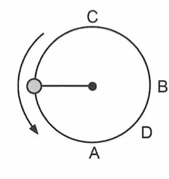

page20image16750976page20image16751360

(a) In the table below, match the statements with A, B, C and/or D. (4 marks)

|  |  |
| --- | --- |
| **Statement** | **A, B, C and/or D** |
| point(s) where the centripetal acceleration is the greatest |  |
| point(s) where the tension in the string is the lowest |  |
| point(s) where the net force is not toward the centre of the circle |  |
| point(s) where the ball’s weight force is perpendicular to the tension |  |

(b)   Write an expression for the net force acting on the string at point C in terms of the weight force and the tension in the string. (1 mark)

(c)   Calculate how fast the 5.00 x 102 g ball can be moving at point A for the 1.20 m long string not to break, if the maximum tension it can withstand at point A is 172 N.

(4 marks)

(d) Calculate the maximum speed at which the ball can be moving at point C for the string

not to break at point A. (3 marks)